The Gran View: Verbal abuse can leave scars for a lifetime
Source: Shayama Chona, Educationist, Padma Bhushan and Padma Shri awardee
“You’re a stupid idiot”;”You are blind”; “You are all a bunch of fools”. It is a myth in the minds of some parents that only sticks and stones may break the bones but insults such as above will never hurt their kids. Parents, for many generations, have actually taught children abusing and name calling. It actually moves from parent to child unknowingly. They must understand that their behaviour also affects the minds and hearts of all family members. Even pets and domestic help can get scared.
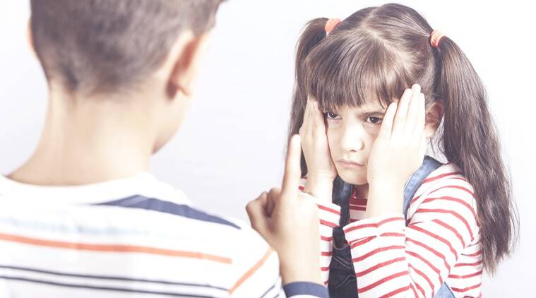
Let children know that all verbal outbursts are against norms of civil behaviour and universal culture. This way of life will not be acceptable. Learning this at an early age will help them to reject this mode of behavior, which they may be exposed to within the family or from society. They must realize that making fun of others, be it their body size, colour of the skin, accent, physical or mental disabilities can lead to hurting the feelings of others.

Sometimes, young children do not know the meaning of the words adults use, but they can gauge that these words definitely fetch a reaction. Children have to be taught that use of bad language or verbal abuse is as hurtful as being physical violent or even throwing objects in a rage. If a child is getting into the habit of reacting badly, you could say, “When you shouted and said those words, I understand that you may have been really upset at something someone else did.” This shows her simply that what she did was wrong and she should mend her ways. Name calling hurts and does not solve problems. This is better than reacting in anger yourself and losing the opportunity to send a message to the child.
Talk right away also to the child who has been a target of hurtful words. Sometimes, parents and teachers become so involved with the angry child that the one who has been at the receiving end gets lost in the shuffle. Even when they don’t completely understand the meaning of the words hurled at them or don’t want to express their hurt, they can still be feeling devastated. Let children know that it’s okay to show their hurt, anger or dejection when they have been shouted at or insulted. If left unacknowledged, children who have been hurt may themselves become victimizers in future. Give your children time and opportunities to express how they are feeling.

Often, children may ask why adults behave in an irrational manner. There is no right answer for this. We can’t know what motivates other people to act the way they do. At times, we don’t even know why we react in certain ways. But, when it comes to children, parents need to have the right responses when they are the targets of uncivilized behaviour. Don’t avoid you’re their questions, even if you don’t know “why”. Your child wants to hear your voice and be assured that no harm will be done to them at home or outside.

